**JAVA concurrency**

# Life Cycle of a Thread

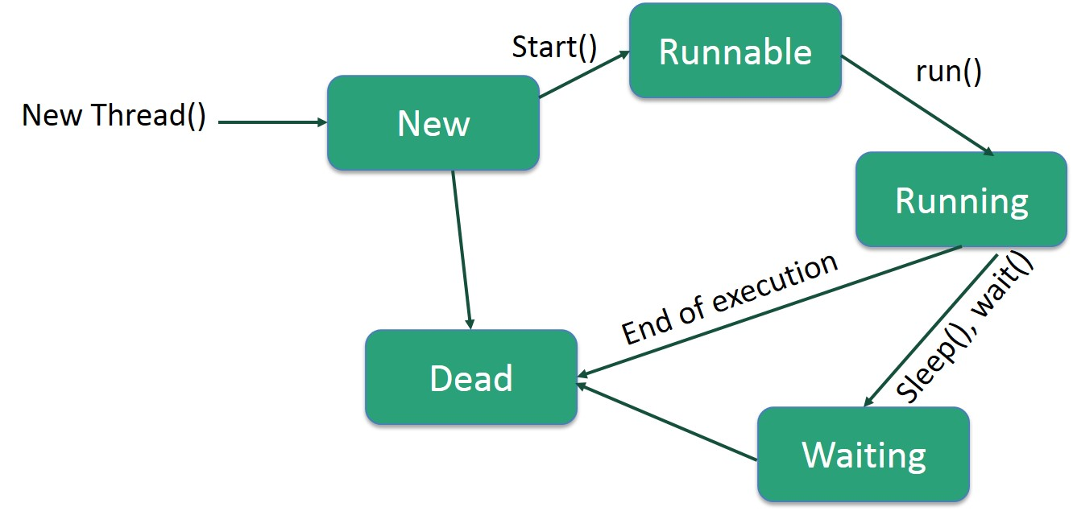

* **New** − A new thread begins its life cycle in the new state. It remains in this state until the program starts the thread. It is also referred to as a **born thread**.
* **Runnable** − After a newly born thread is started, the thread becomes runnable. A thread in this state is considered to be executing its task.
* **Waiting** − Sometimes, a thread transitions to the waiting state while the thread waits for another thread to perform a task. A thread transitions back to the runnable state only when another thread signals the waiting thread to continue executing.
* **Timed Waiting** − A runnable thread can enter the timed waiting state for a specified interval of time. A thread in this state transitions back to the runnable state when that time interval expires or when the event it is waiting for occurs.
* **Terminated (Dead)** − A runnable thread enters the terminated state when it completes its task or otherwise terminates.

# Thread Priorities

Every Java thread has a priority that helps the operating system determine the order in which threads are scheduled.

Java thread priorities are in the range between MIN_PRIORITY (a constant of 1) and MAX_PRIORITY (a constant of 10). By default, every thread is given priority NORM_PRIORITY (a constant of 5).

Threads with higher priority are more important to a program and should be allocated processor time before lower-priority threads. However, thread priorities cannot guarantee the order in which threads execute and are very much platform dependent.